Name: Twana Nariman Qadir Dep: IT 1st G A

|  |  |  |  |  |  |  |
| --- | --- | --- | --- | --- | --- | --- |
| 15a | | | (A.B)’=A’+B | 15a | | |
| A | B | Output | = | Output | B | A |
| 0 | 0 | 1 | = | 1 | 0 | 0 |
| 0 | 1 | 1 | = | 1 | 1 | 0 |
| 1 | 0 | 1 | = | 1 | 0 | 1 |
| 1 | 1 | 0 | = | 0 | 1 | 1 |

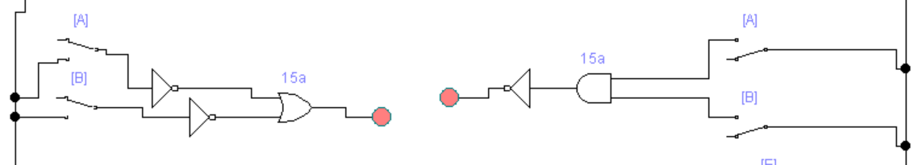

|  |  |  |  |  |  |  |
| --- | --- | --- | --- | --- | --- | --- |
| 15b | | | (A+B)’=A’.B’ | 15b | | |
| A | B | Output | = | Output | B | A |
| 0 | 0 | 1 | = | 1 | 0 | 0 |
| 0 | 1 | 0 | = | 0 | 1 | 0 |
| 1 | 0 | 0 | = | 0 | 0 | 1 |
| 1 | 1 | 1 | = | 1 | 1 | 1 |

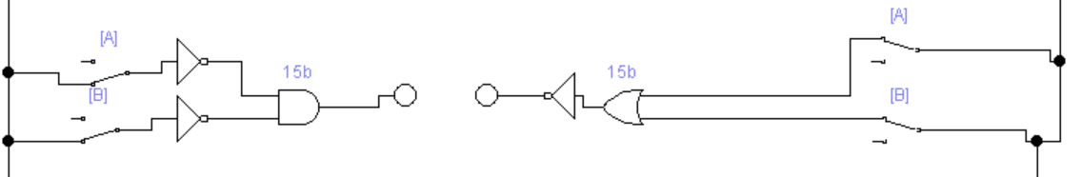

|  |  |  |  |  |  |  |
| --- | --- | --- | --- | --- | --- | --- |
| 16b | | | A.(A’+B)=A.B | 16b | | |
| A | B | Output | = | Output | B | A |
| 0 | 0 | 0 | = | 0 | 0 | 0 |
| 0 | 1 | 0 | = | 0 | 1 | 0 |
| 1 | 0 | 0 | = | 0 | 0 | 1 |
| 1 | 1 | 1 | = | 1 | 1 | 1 |

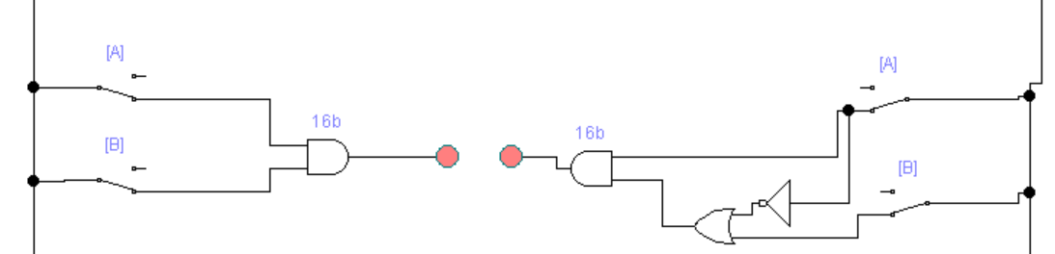

|  |  |  |  |  |  |  |  |  |  |  |
| --- | --- | --- | --- | --- | --- | --- | --- | --- | --- | --- |
|  | 17a | | | | A.B+B.C+A’.C=A.B+A’.C |  | | 17a | | |
| A | | B | C | Output | = | Output | C | | B | A |
| 0 | | 0 | 0 | 0 | = | 0 | 0 | | 0 | 0 |
| 0 | | 0 | 1 | 1 | = | 1 | 1 | | 0 | 0 |
| 0 | | 1 | 0 | 0 | = | 0 | 0 | | 1 | 0 |
| 0 | | 1 | 1 | 1 | = | 1 | 1 | | 1 | 0 |
| 1 | | 0 | 0 | 0 | = | 0 | 0 | | 0 | 1 |
| 1 | | 0 | 1 | 0 | = | 0 | 1 | | 0 | 1 |
| 1 | | 1 | 0 | 1 | = | 1 | 0 | | 1 | 1 |
| 1 | | 1 | 1 | 1 | = | 1 | 1 | | 1 | 1 |

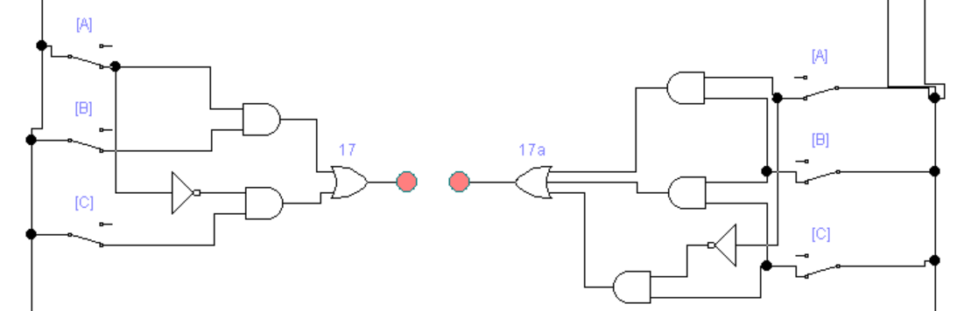

|  |  |  |  |  |  |  |  |  |  |  |
| --- | --- | --- | --- | --- | --- | --- | --- | --- | --- | --- |
|  | 17b | | | | (A+B).(B+C).(A’+C)=(A+B).(A’+C) |  | | 17b | | |
| *A* | | *B* | *C* | *Output* | *=* | *Output* | *C* | | *B* | *A* |
| 0 | | 0 | 0 | 0 | = | 0 | 0 | | 0 | 0 |
| 0 | | 0 | 1 | 0 | = | 0 | 1 | | 0 | 0 |
| 0 | | 1 | 0 | 1 | = | 1 | 0 | | 1 | 0 |
| 0 | | 1 | 1 | 1 | = | 1 | 1 | | 1 | 0 |
| 1 | | 0 | 0 | 0 | = | 0 | 0 | | 0 | 1 |
| 1 | | 0 | 1 | 1 | = | 1 | 1 | | 0 | 1 |
| 1 | | 1 | 0 | 0 | = | 0 | 0 | | 1 | 1 |
| 1 | | 1 | 1 | 1 | = | 1 | 1 | | 1 | 1 |

